Autonomous Driving Car Technology Development Trend

Min-Joon Kim¹, Jong-Wook Jang²

Department of Computer Enginerring, Dong-Eui University
176, Eomgwang-ro, Busanjin-gu
Busan, Korea
zanenber@naver.com¹, jwjang@deu.ac.kr²

Abstract

Self-driving cars have three main functions. The first recognizes the surrounding environment, judge the risk, and lastly plans the drive path. Therefore, the driving operation is minimized. And it refers to a human friendly car capable of safe driving on its own. The reason for the need for self-driving car was to reduce traffic jams on limited roads and to reduce carbon dioxide emissions. Future Cars The three main keywords are connected cars, autonomous vehicles, and electric vehicles. Automotive technology is currently described as the same technology as ADAS, and increasingly technological performance is becoming increasingly variable and diversifying. Connected cars refer to vehicles that connect information and communication technologies to automobiles, enabling vehicles such as V2 and mobile services to be equipped with new services. Electric cars are vehicles that use electric batteries and electric motors without using fossil fuels and engines. Driving ahead of these self-driving car businesses can be expected to attract and expand the existing business and expand the new business and create new business opportunities for ICT firms. It is urgent for the concerned agencies to establish legal and institutional basis for self-driving cars. By doing so, new services could be provided to consumers. Therefore, this paper introduces the technological development trends for self-driving cars.

Keywords-Self-driving Car; Autonomous Vehicle; Autonom ous Avoidance; Technological Development Trends

I. Introduction

The new car market is rapidly grow new markets, with the combination of technology advances and market demands. The present automobile is a mobile body for transportation or a mobile body capable of supporting driving, but in the future, autonomous driving will be possible and the interior of the automobile will be changed into living space and office space. Therefore, SW, artificial intelligence, communication, security, sensor, navigation technology will be added in the current general car, so that autonomous navigation will be possible in the future. Domestic industries are lagging behind in predicting future markets. Therefore, it is necessary to occupy the future of future markets based on automobile and ICT convergence technology, which is the strength of the domestic industry. Autonomous vehicles refer to a human-friendly car capable of self-safety by recognizing the surrounding environment itself, determining the risk, planning the driving route, and minimizing the driver's driving operation. The changes in the automobile industry are accelerating commercialization of ADAS, technological progress, easing of cost burden, and intensifying competition among companies to secure future markets. Consumer demand is also increasing, such as improving safety and convenience, and reducing oil costs. The three key words of future cars are connected cars, autonomous vehicles, and electric cars. Connected cars are defined as a concept that emphasizes the connectivity of vehicles. Various devices inside the vehicle are connected to the external network through wireless communication, providing information for improving the safety and convenience of the vehicle, real-time navigation, remote vehicle control and management Refers to vehicles that support infotainment services. Definition of autonomous driving car refers to a car that recognizes its surroundings by itself and drives safely without accident by judging driving routes and risks. Electric cars are cars that use electric batteries and electric motors, not fossil fuels and engines. In this paper, technology development trends of autonomous vehicles are analyzed.[1]

II. Autonomous Driving Car Technology Trend

Currently, cars support driving, such as moving a simple transport vehicle or maintaining lane keeping, parking aid, and distance maintenance. However, as the autonomous driving becomes possible in the future, the automobile can become a living space and an office space. Future markets are being created and growing as the technology advances and automotive market demands combine. The automobile market is now a market for finished car makers. However, future autonomous vehicles will emerge with automobiles incorporating software, information, artificial intelligence, communication, security, sensors and navigation. Therefore, it is predicted that companies developing sensors, parts and systems for automobiles will show a strong performance in the automobile market. Domestic industries are slowing down compared to the autonomous cars market, as existing automotive and IT industries such as BMW and Google are announcing their R & D plans and performance for fully autonomous cars. Therefore, it is necessary to preoccupy the future market based on the automobile and ICT convergence technologies, which are the strengths of the domestic industry. Smart automobile is able to provide high safety and convenience service by real-time recognition of the internal and external situation of the automobile by combining electric technology, information communication, and intelligent control technology with automobile technology.[2][3]

A. Autonomous vehicles

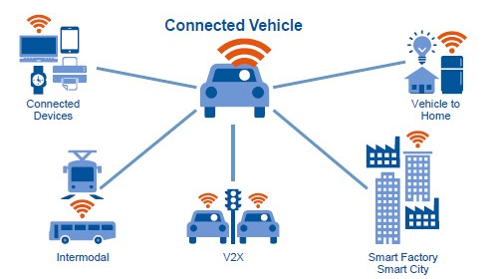
Autonomous vehicles refer to a human-friendly vehicle that recognizes its own environment, judges the risk, plans the driving route, minimizes driver's driving operations, and is capable of running safely on its own. Autonomous driving is largely divided into 5 stages as shown below.
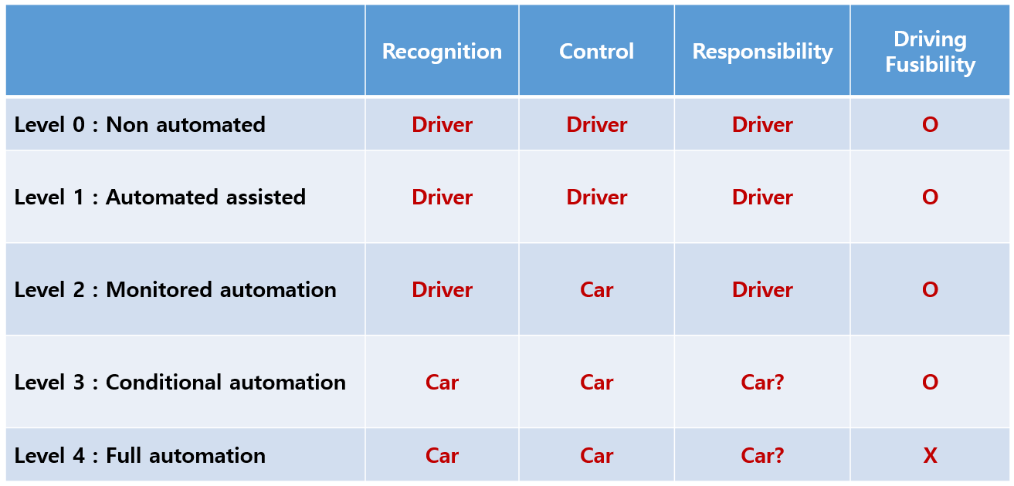
Fig. 1. Definition of technology stage of autonomous vehicle

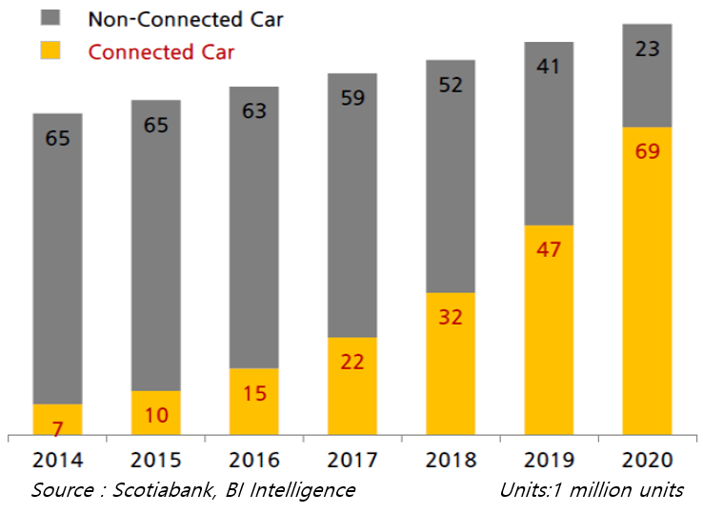
The current phase is an integrated ADAS phase that combines ACC + LKAS with Level 2, and functions like the GM Cadillac's Super Cruise function. Level 2 is the stage where the driver must always be aware of the surrounding traffic situation. In the case of a Google autonomous vehicle, it will be at Level 3, and as of yet there is a case of a traffic accident caused by an autonomous vehicle problem. Autonomous vehicles are being developed as a fusion of vehicle technology and infrastructure technology. It will be composed of the integrated control of the automobile - infrastructure that efficiently collects and manages various data such as sensors, vehicle information, traffic speed, traffic volume, density, weather information and road surface condition data.
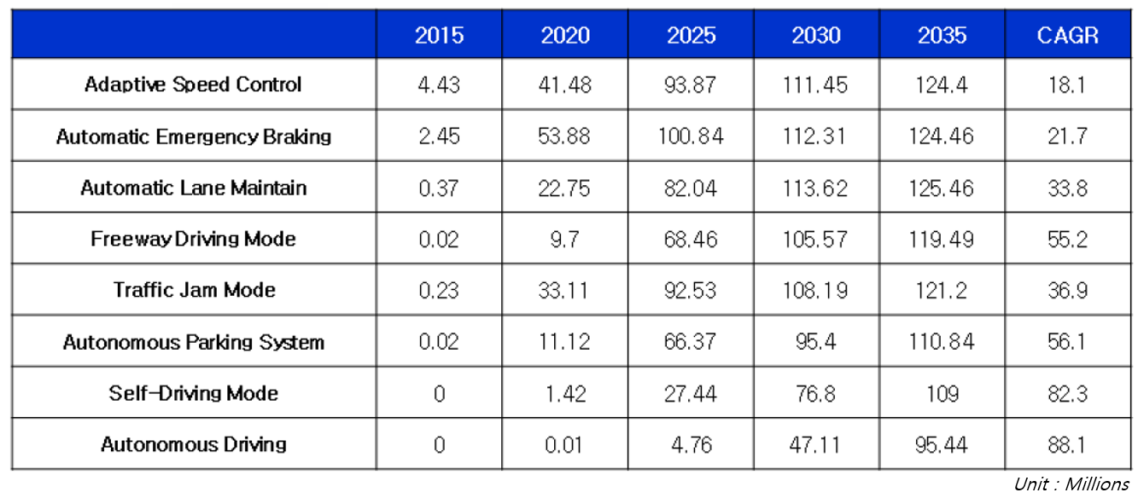
Fig. 2. Autonomous vehicle market forecast, 2015 ~ 2035

Consumers of autonomous vehicles said that 37 percent of them said that it is the purchase of autonomous vehicles. Even if the price is offered at $ 3,000, 20% of consumers are responding positively to autonomous vehicles. The IEEE also said that by 2040 autonomous vehicles are expected to account for 75 percent of the world's cars. It also demonstrates the effectiveness of safety regulations. AEB technology is applied as a basis for reinforcing global safety regulations while seeing the effects of collision mitigation.

B. Connected Cars
Connected car is a concept that emphasizes the connectivity of vehicles. Various devices inside the vehicle and external network are connected through wireless communication, providing information for improving safety and convenience of the vehicle, real-time navigation, remote vehicle control and management, e-mail, multimedia streaming, And other infotainment services.

Fig. 3. Definition of Connected Vehicle

IT companies are competing to develop automotive infotainment platforms. In the future, the scope of technology will be expanded to V2X, which enhances safety through communication between various objects and helps efficient operation. It is expected to increase the demand for customized information and contents by analyzing big data such as driver's driving and life patterns. Techniques for enhancing convenience by expanding interconnectivity between automobiles and other devices will be developed. The market for connected cars is expected to account for 75% (69 million units) of connected cars among the world's automobile production volume of 92 million in 2020.

Fig. 4. Connected Car Market Size

The rapid increase in vehicle connectivity is expected to increase digital content consumption and production, and will affect overall automotive service functions such as infotainment. We expect automobile and IT companies to contribute to various business models and revenue sources.
C. Electric cars

Electric cars are cars that use electric batteries and electric motors without using fossil fuels and engines. The core technologies of electric vehicles are batteries, drive motors, chargers, high-voltage, and power conversion technologies, aiming at low cost and high efficiency. Electric vehicles can be categorized as shown in the following figure, depending on whether all of the electric energy is supplied from the outside or whether the electric energy is generated by itself.
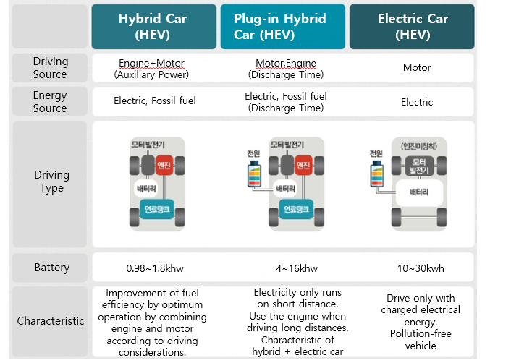
Fig. 5. Types of electric cars

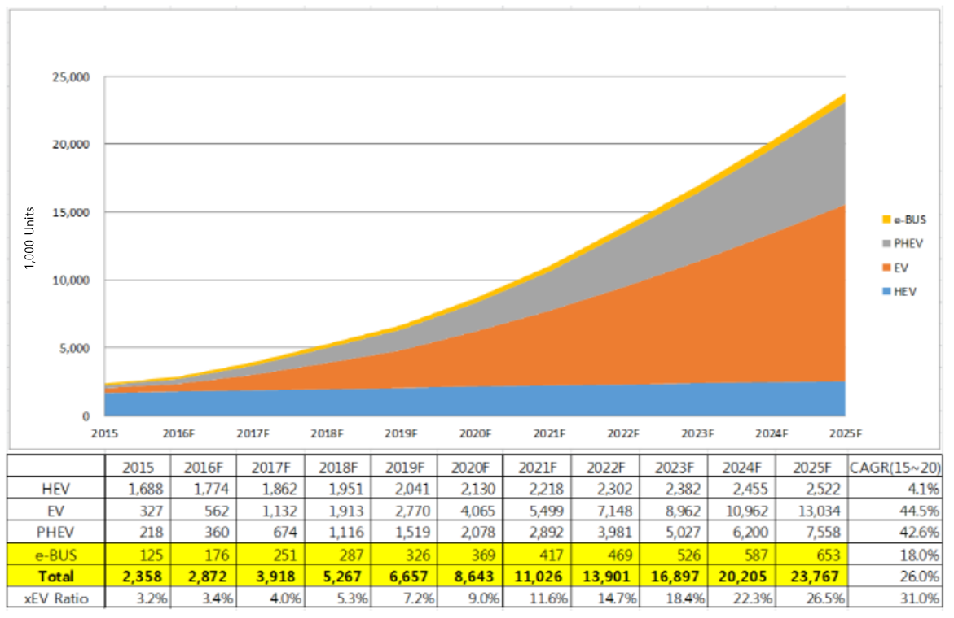
An electric vehicle is a pure electric vehicle (EV) that operates only from a battery charged with electric energy from the outside in a narrow sense. In the broad sense, it refers to a hybrid electric vehicle (HEV) using an engine and a motor, A plug-in hybrid electric vehicle (PHEV) that can be charged from a power source of the vehicle.[4]

Fig. 6. World Electric Vehicle Market Outlook

The global electric car market is expected to sharply increase from 2.77 million units this year to 23.76 million units by 2025 due to strengthened environmental regulations and full support from the Chinese government. SNE Research a global electric vehicle market research organization is expected the number of EVs shipped worldwide will reach 2.87 million units this year, with EV (pure electric vehicle) and PHEV (plug-in hybrid electric vehicle) excluding hybrid cars reaching 920,000 units.

III. Sensor Technology Trends of Autonomous Driving Vehicles

Autonomous vehicle sensor technology consists of various sensors such as ultrasonic, vision camera, radar, and Lidar. For front, rear and side cameras, it is applied to the surround view monitor and parking assist technology. For front camera and infrared camera, it is applied to auto braking system, night vision, pedestrian protection, lane keeping, black box, intelligent up light control function. The near-field radar sensor is used for detection range of 0.5 ~ 70m, and is used for blind spot protection, lane change and rear collision detection. The rear and front ultrasonic sensors are used in parking assist systems with a sensing distance of 0.3 to 2.5 meters. In the case of lateral ultrasonic sensors, the detection range is 0.3 ~ 5.0m, which is used for smart parking function. Finally, the radar sensor is used in SCC, Stop & Go, front collision detection auto braking system, etc. with a detection range of 0.5 ~ 200m. Camera sensors such as mono cameras and stereo cameras, which are typical sensors, are vulnerable to extraneous influences such as backlighting and tunnels, and the accuracy of distance is reduced. In the case of a radar or a Lidar sensor, pedestrians, lanes, and signs are difficult to recognize. Therefore, new sensor technology such as depth camera is being developed and new recognition technology is developed by fusing various sensors. The development status of commercialization of autonomous driving car is as follows: Development of technology for integrated image recognition SW and driving support system for driving lane, opposite vehicle, leading vehicle, development of stereoscopic camera system for HD car with less than 5% error rate, 3D LIDAR Development of sensor system, development of high-definition 3D-HDR camera and integrated image processing module for parking and lane change driver support, and development of mirrorless camera system.

IV. Conclusion

In this paper, we briefly analyzed the technology trends of autonomous vehicles. Growth was delayed because the domestic industry of autonomous vehicles could not predict the growth potential of autonomous car market. Therefore, technology development research is needed to secure competitiveness in a short period of time and to enter the global market. In the field of autonomous vehicles, ADAS parts and systems can be developed as follow-on projects, which will help automakers maintain and expand existing businesses. In addition, the paradigm shift will lead to new business creation and entry into the automotive industry with the introduction of new and challenging ideas and functions. Consumers may require traffic accident reduction and new services. In order to expand these industries, the legal and institutional basis of the nation should be provided, such as revision of relevant laws, identification of traffic accidents, and evaluation criteria for autonomous driving performance.

Acknowledgment

This research was supported by the MSIP(Ministry of Science, ICT and Future Planning), Korea, under the Grand Information Technology Research Center support program (IITP-2017-2016-0-00318) supervised by the IITP(Institute for Information & communications Technology Promotion)
This research was supported by The Leading Human Resource Training Program of Regional Neo industry through the National Research Foundation of Korea(NRF) funded by the Ministry of Science, ICT and future Planning(grant number)(NRF-2016H1D5A1910985)
References

[1] Technology development and business strategy of high -tech automobile and core electric parts, Institute of Industrial Education
- KB knowledge vitamin: Domestic and foreign unmanned mobile industry, KB Financial Group
- Development of unmanned mobile industry and development of unmanned mobile vehicles for job creation 5 years (draft), National Science and Technology Council
- Types and Future of Electric Vehicles, SAMSUNG SDI

